VirtuSafe+: AI-Powered Digital Twin for Home Safety and Energy Resilience in Smart Urban Living

Nandita Patni
Department of Computing Technologies
SRM Institute of Science and Technology, Kattankulathur
Chennai, India np6156@srmist.edu.in

Dr. R. Lavanya
Department of Computing Technologies
SRM Institute of Science and Technology, Kattankulathur
Chennai, India lavanyar@srmist.edu.in

Abstract—Smart home safety systems are usually based on reactive notifications that are activated when the hazardous conditions have surpassed the pre-determined thresholds. These strategies restrain early intervention and risk prevention. This paper introduces VirtuSafe+, a Digital Twin prototype of a smart home safety monitoring and initial risk assessment based on simulation. The proposed system has an online model of the most important environmental parameters, namely temperature, smoke level and power consumption, based on artificially gen- erated instances of time series to simulate the real-time sensor dynamics.
A decision engine, which is governed by rules, works on the Digital Twin state to categorize system conditions as safe, warning, or hazardous, whereas short-term trend variations are studied to give timely alerts about the rapidly changing situations. The Python language is used to implement the system, which will have real-time visualization and interaction via a web-based dashboard and continuous data logging.
Experimental analysis is achieved by controlled simulation case study, which proves good state-synchronisation, constant alert- generation, as well as, good visualisation of system behaviour. The findings confirm the practicability of simulation-based Digital Twins to act as a base of smart home safety systems. The architecture suggested is capable of accommodating the physical sensors and machine learning models in the future and allow the gradual development of intelligent and real-world deployments.

- Introduction
The use of smart home technologies has become widespread due to its ability to increase the comfort, energy efficiency, and safety. Modern residential properties rely more on connected systems and sensors to monitor air quality and temperature in a house and incoming electricity usage constantly. Nonetheless, with these technological improvements, most of the existing smart home safety systems are rather reactive; they will only provide alert when the preset thresholds are surpassed. These are delayed responses that limit on-time interventions and increase the likelihood of damage or injury.

Vishwajeet Kumar
Department of Computing Technologies)
SRM Institute of Science and Technology, Kattankulathur)
Chennai, India vk2247@srmist.edu.in

Traditional safety monitoring schemes usually consume sen- sor information separately without maintaining a continuous image of the system state or its historical dynamics. As a result of this, these systems are usually not contextually aware, and therefore unable to predict a risky situation before it has developed fully. The abovementioned limitation obtains a certain relevance in the environment of safety-related issues, such as fire hazards, electrical overloads, or quickly varying environmental conditions.
A promising alternative is that of Digital Twin technology, which allows developing a virtual image or model of a real or simulated physical space that develops in parallel with the real or simulated data streams. A Digital Twin stores not the state of the existing system, but also the past dynamic, therefore, making it easier to make more informed decisions and proac- tively monitor the situation. Even though Digital Twins have been studied in industrial systems and large infrastructures, their implementation to the safety systems of smart homes, particularly, in the early prototyping and simulation stage, is relatively underresearched.
This paper presents a proposal VirtuSafe+, a simulative Digital Twin prototype that was suggested to investigate the viability of a Digital Twin-siafety monitoring in smart-home settings. The suggested frame focuses on the framework of ar- chitectural design, the synchronization of states and decision- logic verification based on the use of synthetic sensor infor- mation. Through an adoption of a modular, software-defined prototyping, this research project will permit controlled testing and trial-and-error before the actual deployment into the real world.
The main focus of this study does not include the develop- ment of a full-fledged smart home solution; instead it will be an effort to develop a skeleton of Digital Twin-based safety monitoring. The prototype will be used as a benchmark to test the behaviour in the system, the accuracy of decisions and the effectiveness of visualization, and illustrate a clear path of the

future integration of physical sensors and machine-learning- based risk prediction models.
- Related Work
Smart home safety and monitoring systems has been consid- ered by a large amount of academic research on the Internet of Things (IoT). The first methodologies are either mainly based on distributed sensor networks to measure, e.g., temperature, smoke concentration, and energy consumption, and alert on violation of pre-defined thresholds. Although these systems provided single-purpose levels of monitoring, they are largely reactionary and relatively poor in contextual awareness and usually result in slow reactions, or random alarms.
The use of machine learning and artificial intelligence models to improve smart home safety systems is a recent study that has been investigated. Pattern recognition methods and controlled learning have been used to differentiate between the normative and unusual states of the environment thus enabling easier and more data adaptive decision making. However, these methods usually require large amounts of labeled data, and many of them are designed in the context of lacking a consistent representation of system state, hindering the study of behavior across time and the modeling of system evolution. Digital Twin technology has become an interesting paradigm to fill this gap by maintaining a virtual representation of physical systems that aligns with real-word or simulated data in real-time. Domestic Digital Twins have been suc- cessfully used in industrial automation, smart industry, and infrastructure monitoring at large scale, thus aiding in predic- tive maintenance and optimizing operations. These systems utilize previous history, simulation, and analytics to augment
the situational awareness and make decisions.
In the smart home context, the available literature on Digital Twin-based research projects is mostly focused on the field of energy management, the process of building-performance assessment or theoretical architectural modeling. Many of the proposed solutions favor the high-fidelity simulation and full deployment, often based on the existence of actual physical sensors and advanced analytics pipelines. Thus, there is a lack of research in the literature related to early-stage Digital Twin prototypes, which operate through simulation and con- firm architectural design and decision logic before hardware intertwining.
The current research is unique since it focuses on a simulation-based Digital Twin prototype that is specific to smart home safety monitoring. Instead of deploying a complete system, the intended methodology project shadows architec- tural disclosure, state synchronization and rule-based decision validation using artificial sensor data. Coming out clearly to face the prototyping phase, such a research enhances the prior literature and provides a realistic base to evolve through iteration towards the intelligent and functional smart home safety systems.

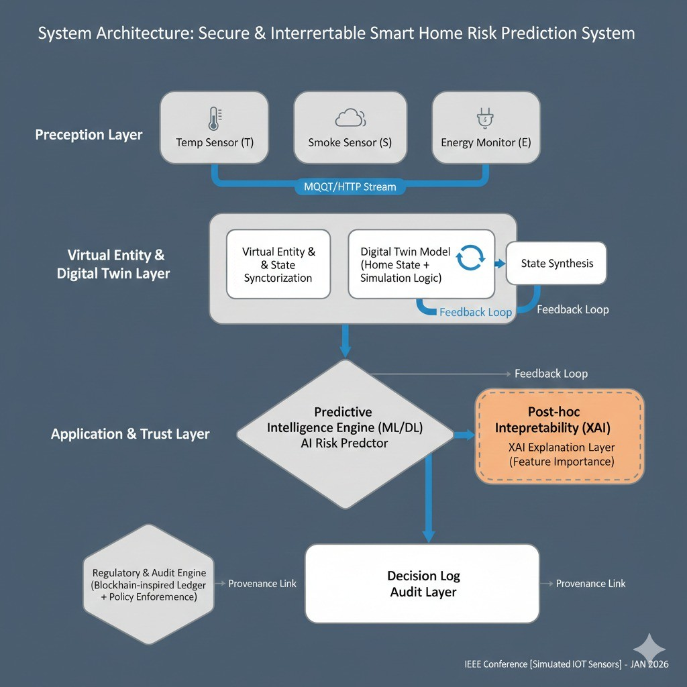

Fig. 1. System Architecture of the Proposed Model

The architecture focuses on state persistence, separation of concerns and extensibility, which allows early validation of the software using simulation and also provides compatibility with real-life deployment in the future. The architectural layers are structured to have a distinctly defined task thereby being robust, interpretive, and scalable.
The Digital Twin is the central part of the system, that is, a constantly updated virtual model of the smart home environment. This Digital Twin mediates all sensing, decision making and visualization processes which give the system uniform behavior and centralized state control.
- Simulated Perception Layer
The virtualized perception layer will be in charge of simu- lating sensor behavior in the real world without the physical equipment. In this prototype, this layercreated fake time-series values of the most important environmental parameters, such as temperature, the level of smoke, and power consumption.
The sensor values are changed in constant intervals based on regulated stochastic changes and represent gradual changes in the environment instead of sharp-scale fluctuations. The design option allows the realistic modeling of the real-time sensing behavior and also provides the ability to test both the normal and abnormal operating conditions in an controlled manner.
An architectural view of this layer is that it is a replace- able abstraction. Simulated data generators can be effortlessly substituted by real-world sensors or IoT data feeds in the implementation in the future without impacting components of downstream systems.

- Architecture
VirtuSafe+ system is created in the form of a layered Digital Twin based architecture of smart home safety monitoring.
- Digital Twin Core Layer
Digital Twin core layer ensures an ongoing virtual condition of the intelligent home setting. As opposed to the old fashioned

method of monitoring, where sensor readings are processed independently without any memory of past values, the Digital Twin records the current state and a short history list of the past values of each parameter being monitored.
This is the steady state representation that allows:
  - Reasoning in the past about the environment.
  - Early warning generation trend-based analysis.
  - Unifying synchronization within components of the sys- tem.
The Digital Twin is the sole owner of the truth in the whole system. All the decision logic and visualization operations work only with the Digital Twin state and not with actual sensor data, which gives architectural clarity and data coher- ence.
- Decision Engine Layer
The decision engine layer is used to assess the state of Digital Twin by evaluating the system safety and producing the right response. The rule based decision logic implemented in this very layer of the current prototype strives to offer interpretable behavior as well as transparent system behaviour. The decision rules act on the instantaneous values and also the contemporary history trends and can then be classified into safe, warning and dangerous states of the system. Each of the classifications is supported by a system recommendation
aimed to provide user response.
The decision engine is also architecturally unlinked with the Digital Twin core, thus it can be swapped or supple- mented with machine learning-based inference models during subsequent iterations without making the system structure alterations.
- Data Logging and Audit Layer
The system has a specific data logging and audit layer to ascertain traceability and reproducibility. The Digital Twin state at a given time, the results of the made decisions and the recommendations are stored in a structured time-series format at every system iteration.
This is a logging mechanism that is used in a variety of ways:
  - System behavior analyzed off-line and appraised. testing and checking the decision logic.
  - Generation of a dataset that will be used in future machine learning.
The system makes all the decision making processes auditable and transparent through the inclusion of logging in the archi- tecture.
- Visualization and Interaction Layer.
Monitoring system behavior is offered in real time by the visualization and interaction layer. A web-based dashboard will make available the current Digital Twin values, system status indicators, and past trends in a user-friendly format.
This layer will increase the interpretability of the system by enabling the users to monitor the effect of the alteration in the environmental parameters on the decision outcome. Simple
interaction controls allow users to initiate system execution, interrupt system execution and view controlled system execu- tion, facilitating experimental evaluation and demonstration.
Notably, this layer is firmly uncoupled with core system logic and therefore the visualization does not affect the decision-making processes.
- Principles of architectural design.
VirtuSafe+ architecture is informed with a set of principles that include the following design principles:
  - Modularity: The system components have a specific task which they execute and can be changed separately.
  - Full of capabilities: The architecture allows easy integra- tion of actual sensors, machine learning models, as well as advanced analytics.
  - Transparency: Interpretability is made possible through rule-based decision logic and explicit representation of state.
  - Simulation-First Validation: This allows an early stage analysis without hardware dependency.
The following principles will make sure that the proposed architecture is gungy in both phases of system maturity, when it is suggested by prototyping through simulation, and when it is implemented in the real world.
- Implementation Details
VirtuSafe+ prototype is designed as a software-defined platform based on Python in accordance with the modular architecture, outlined in the foregoing section. Its implementa- tion aims at verifying Digital Twin state management, decision logic execution, and real-time visualization in a simulation- based environment.
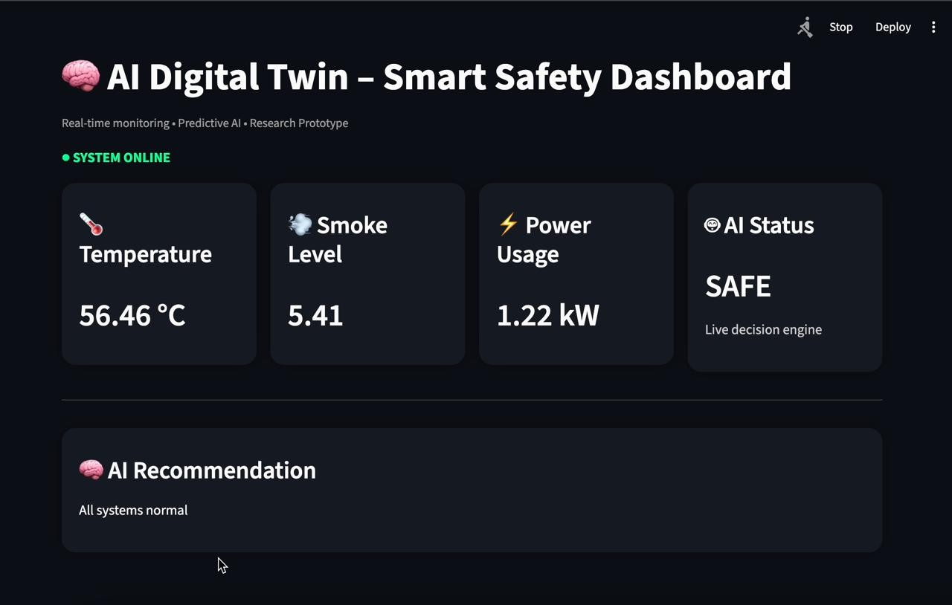

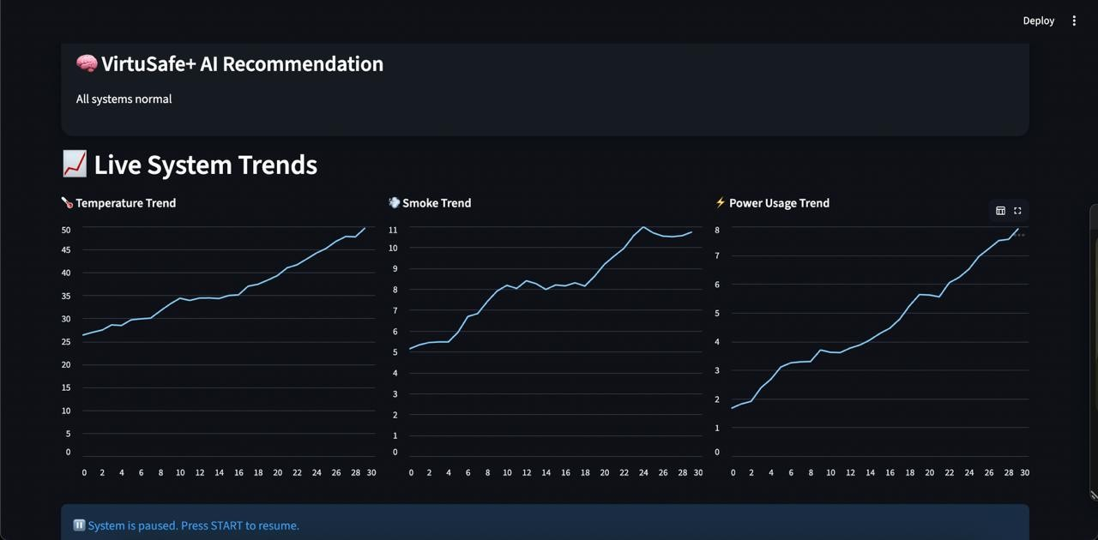

- Digital Twin and Decision Engine Implementation.
The decision engine and Digital Twin core is deployed in a continuous execution cycle. The environmental parameters such as temperature, amount of smoke, and power consump- tion are modeled as state variables in the Digital Twin and updated at predetermined time intervals.
The rule-based decision engine is directly acted on top of the Digital Twin state. The decision rules consist of the design that uses the real time values of the parameters as well as historical trends over the short term. According to these assessments, the system is divided into set safety categories and provides specifications with recommendations to the present state.
This implementation forms a clear and comprehensible base of validating system behavior and guides the learning based extensions in the future.
- Data Logging Mechanism
Decision output and updates on system state are recorded in a well-defined commaline values (csv) format. Every entry in the log contains a time, the current value of the Digital Twin parameters, the type of the system, and the recommendations produced.
- Visualization Dashboard
Dashboard is done using a lightweight application structure whereby it creates real time picture of the system behaviors. The dashboard shows the existing values of Digital Twin, the indicators of the system status, and the past trends based on data logged in.
The system features user interaction which enable the moderated operation of the system such as the initiation and stopping of the simulation. The dashboard does not depend on the actual system logic related to making decisions so that visualization is not part of decision making.
- System Operation and Time management.
The system is run at a constant execution time step concept with state run and decision run taking place at fixed intervals. Such a method approximates real time monitoring behavior as well as determining deterministic and reproducible system behavior in simulation.
Timing of execution The ability to be able to execute the ex- periment under the same conditions and ease the performance analysis across a variety of simulated scenarios.
- Experimental Setup
An assessment of the system is conducted based on syn- thetic sensor data of the environmental parameters in a smart home. Power consumption, level of smoke and temperature are taken into account. These values are updated periodically in order to be considered a continuous sensing behavior.
The simulation runs on a regular computing configuration in Python. The model used in the execution of systems is fixed time-step, which guarantees the deterministic nature of behavior and repeatability of the system according to experiment runs. The states of all the systems and output of
the decisions are logged in an organized time-series format to be analyzed.
- Evaluation Scenarios
Several simulated scenarios are taken to investigate the behaviour of the system in various conditions:
  - Normal Operation Scenario: The conditions of the environment are influenced by variations to safe levels, which are natural conditions in a household.
  - Gradual Escalation of Risk Scenario: A single or a group of parameters grow steadily with time, modelling the appearance of hazardous conditions, such as warming or increased power consumption.
  - Threshold Breach Scenario: Parameters reach and ex- ceed a predetermined threshold of safety conditions, indicating immediate risk.
Such scenarios can be used to test the capabilities of both reactive detection and early warnings due to the use of historical trend analysis.
- Evaluation Metrics
Qualitative and functional measures are used to evaluate the performance of the system at the prototyping stage:
  - State Synchronization Consistency: Confirmation of the Digital Twin’s ability to capture simulated sensor observations at every time step.
  - Decision Correctness: Evaluation of compliance be- tween system classifications (safe, warning, dangerous) and simulated environmental conditions.
  - Alert Responsiveness: Measurement of the response time of the system to changes in safety states.
  - Visualization Accuracy: Confirmation that the display dashboard matches the logged system states.
These measures focus on architectural correctness and be- havioral validity rather than numerical optimization.
- Equations
1) Logistic Regression-Based Risk Estimation: The proba- bility of an unsafe condition is modeled using logistic regres- sion as:
P (y = 1 | x) = σ(w^{T} x + b) (1) where the sigmoid function σ(z) is defined as:
1
σ(z) = 1 + e−z (2)
- Results and Observations
The findings of the experiments confirm that the Digital Twin has a consistent system state when run on a simulation. Under all of the conditions tested, the decision engine identi- fies system conditions properly and gives out the correspond- ing safety recommendations to gradual and abrupt changes in the environment.

The analysis based on trends allows to offer early signals in those situations when the parameter values are gradu- ally increasing, which proves the advantage of the historical framework compared to the instantaneous monitoring with threshold. The visualization dashboard is a good representation of the system behavior and offers real-time data on the state transition as well decision process.
In general, the analysis validates the hypothesis that the suggested architecture facilitates the stability of the state synchronization, interpretable decision-making, and effective monitoring in the context of simulation-based setting.

- Discussion
In the case of VirtuSafe+, the design and testing processes indicate the possibility of using a Digital Twin-based model to monitor the safety of smart homes at the stage of raw pro- totyping. The findings reveal some valuable lessons associated with system design, decision-making, and the simulation value of safety-critical research.
Among the observations is the fact that persistent Digital Twin status increases understandability and predictability of the system tremendously. Contrary to conventional sensor- based systems that act on data independently, the Digital Twin allows centralized state control and trend-sensitive thinking. With this design, the system can produce an early warning de- pending on the changing conditions instead of only responding to immediate threshold violations.
The rule-based decision logic was found to be efficient as a baseline mechanism to verify the correctness of architecture and system behavior. Although approaches built on rules are less flexible, their predictability and clarity are useful at an early level of development. The existing implementation proves that meaningful safety assessment can be produced without complicated learning models, assuming that the state of the system and past context are appropriately upheld.
The simulation-based testing was essential in facilitating such fast development as well as controlled experimentation. The proposed approach decouples system validation with physical hardware, enabling architectural and logical compo- nents to be optimised without introducing physical complexity (i.e. sensor noise, communication delays or deployment con- straints). This approach minimizes the risk of development and helps to iterate.
The present prototype, however, also has limitations that are related to the scope of the prototype. The lack of physical sensors only evaluates synthetic data, and use of rule-based logic is only limiting to unexplainable conditions. Also, the accuracy or ability to perform under noisy environments is the type of performance measure that cannot be evaluated completely without real-life information. These shortcomings emphasize the necessity of gradual improvement with sensor fusion and data-based inference.
On the whole, the discussion confirms that VirtuSafe+ should be regarded as a base system, but not as an entire solution of smart home safety. Its main input is in architectural
validation and system behavior analysis to offer a systematic approach to more intelligent and deployable systems.
- Future Works
The present VirtuSafe+ prototype provides a baseline Dig- ital Twin architecture of smart-home safety monitoring with the validation based on simulation. Although the system shows both architectural feasibility and dependable decision behavior, there are a number of opportunities to expand and develop the offered framework.
The major trend in the future working involves incorpora- tion of the physical IoT sensors to substitute the simulated perception layer. Live sensor data would allow testing in a realistic environment, such as noise, latency and variations in hardware. This is critical in transferring the system outside the simulated validation to the actual application.
The other major extension is that of machine learning-based decision models. According to the designed ML methodology, accumulated Digital Twin data may be used to train learning- based classifiers and time-series prediction models to enhance adaptability and prompt risk identification. These models would allow the system to be generalized across different environments and minimize the use of rules that need to be written out by hand.
The fidelity of the Digital Twin can also be extended to other parameters of the environment and setting, e.g. motion activity, occupancy information and spatial layout awareness. The Digital Twin that is more fidelity would enhance situa- tional awareness and aid in performing more holistic safety evaluation.
More work to do in the future can involve strong perfor- mance assessment in real-life situations such as stress tests using noisy data streams, lagging updates and fault situations. Once actual data and learning-based models are available, it would be possible to incorporate quantitative metrics of evaluation in terms of detection accuracy, false positive rates, and response latency.
Lastly, the proposed architecture can facilitate such long- term research areas as explainable decision making, safe data processing and scaling deployment across several smart home settings. These extensions make VirtuSafe+ a versatile research environment to study intelligent, Digital Twin-based safety systems.
- Conclusion
This paper introduced VirtuSafe +, a prototype of a Digital Twin of smart home safety monitoring processes based on simulation. The main aim of this paper was to verify the viability of a Digital Twin-centric design to sustain persistent system state, allow context-sensitive decision-making, and facilitate early-stage safety verification without necessarily using physical hardware.
The suggested system showed that a centralized Digital Twin representation, rule-based decision logic and tracking of historical state could be used to give meaningful safety classifications and early warnings in a controlled simulation

environment. The system was developed using a consistent state synchronization, transparent decision behavior and real- time visualization, through modular architecture, providing a stable base to the iterative development.
System behavior under various simulated conditions of normal operation, gradual risk escalation, and critical threshold conditions was shown to be correct by experimental evaluation using synthetic sensor data. Although the present implemen- tation is not based on the use of physical sensors and the learning-based inference, the results justify the architectural design decisions and can prove that simulation-driven proto- typing is an appropriate choice to use in early smart home safety research.
In general, VirtuSafe+ is a framework instead of an ultimate implementation and focuses on architectural transparency, extensibility and research-intensive implementation. The sug- gested design facilitates the easy incorporation of actual sen- sors, machine learning models, and enhanced analytics into upcoming prototypes and suggests the system as a flexible platform to explore the use of intelligent, Digital Twin-based safety in smart home settings.
References
- M. Grieves and J. Vickers, “Digital Twin: Mitigating Unpredictable, Undesirable Emergent Behavior in Complex Systems,” Transdisci- plinary Perspectives on Complex Systems, 2017. [Online]. Available: https://www.researchgate.net/publication/319367710
- F. Tao, H. Zhang, A. Liu, and A. Y. C. Nee, “Digital Twin in Industry: State-of-the-Art,” IEEE Transactions on Industrial Infor- matics, vol. 15, no. 4, pp. 2405–2415, 2019. [Online]. Available: https://ieeexplore.ieee.org/document/8622374
- A. Al-Fuqaha, M. Guizani, M. Mohammadi, M. Aledhari, and
M. Ayyash, “Internet of Things: A Survey on Enabling Technolo- gies, Protocols, and Applications,” IEEE Communications Surveys & Tutorials, vol. 17, no. 4, pp. 2347–2376, 2015. [Online]. Available: https://ieeexplore.ieee.org/document/7123563
- A. Zanella, N. Bui, A. Castellani, L. Vangelista, and M. Zorzi, “Internet of Things for Smart Cities,” IEEE Internet of Things Journal, vol. 1, no. 1, pp. 22–32, 2014. [Online]. Available: https://ieeexplore.ieee.org/document/6740844
- C. M. Bishop, Pattern Recognition and Machine Learning. New York, NY, USA: Springer, 2006. [Online]. Available: https://www.springer.com/gp/book/9780387310732
- I. Goodfellow, Y. Bengio, and A. Courville, Deep Learning. Cambridge, MA, USA: MIT Press, 2016. [Online]. Available: https://www.deeplearningbook.org
- S. Hochreiter and J. Schmidhuber, “Long Short-Term Memory,” Neural Computation, vol. 9, no. 8, pp. 1735–1780, 1997. [Online]. Available: https://www.bioinf.jku.at/publications/older/2604.pdf
- A. Banks, J. S. Carson, B. L. Nelson, and D. M. Nicol, Discrete-Event System Simulation. Upper Saddle River, NJ, USA: Prentice Hall, 2010.

